TASK 1:
#include <iostream>
#include <queue>
using namespace std;

class node {
public:
int data;
node* left;
node* right;

node(int d) {
this -> data = d;
this -> left = NULL;
this -> right = NULL;
}
};

node* TreeFromArray(int arr[], int start, int end) {
if (start > end) {
return NULL;
}

int mid = (start + end) / 2;
node* root = new node(arr[mid]);

root->left = TreeFromArray(arr, start, mid - 1);
root->right = TreeFromArray(arr, mid + 1, end);

return root;
}

void inOrderTraversal(node* root) {
if (root == NULL) {
return;
}

inOrderTraversal(root->left);
cout << root->data << " ";
inOrderTraversal(root->right);
}

int main() {
int numArr[] = {1, 2, 3, 4, 5};
int n = sizeof(numArr) / sizeof(numArr[0]);

node* root = TreeFromArray(numArr, 0, n - 1);

cout << "In-order traversal of the binary tree: ";
inOrderTraversal(root);
cout << endl;

return 0;
}
OUTPUT:
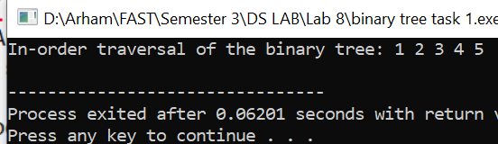

TASK 2:
#include <iostream>
#include <queue>
using namespace std;

class node {
public:
int data;
node* left;
node* right;

node(int d) {
this->data = d;
this->left = NULL;
this->right = NULL;
}
};

node* TreeFromArray(int arr[], int start, int end) {
if (start > end) {
return NULL;
}

int mid = (start + end) / 2;
node* root = new node(arr[mid]);

root->left = TreeFromArray(arr, start, mid - 1);
root->right = TreeFromArray(arr, mid + 1, end);

return root;
}

void inOrderTraversal(node* root) {
if (root == NULL) {
return;
}

inOrderTraversal(root->left);
cout << root->data << " ";
inOrderTraversal(root->right);
}

node* insertValue(node* root, int value) {
if (root == NULL) {
return new node(value);
}

queue<node*> q;
q.push(root);

while (!q.empty()) {
node* current = q.front();
q.pop();

if (current->left == NULL) {
current->left = new node(value);
return root;
} else {
q.push(current->left);
}

if (current->right == NULL) {
current->right = new node(value);
return root;
} else {
q.push(current->right);
}
}

return root;
}

bool isCompleteBinaryTree(node* root) {
if (root == NULL) {
return true;
}

queue<node*> q;
q.push(root);

bool nonFullNode = false;

while (!q.empty()) {
node* current = q.front();
q.pop();

if (current == NULL) {
nonFullNode = true;
} else {
if (nonFullNode) {
return false;
}
q.push(current->left);
q.push(current->right);
}
}

return true;
}

bool isFullBinaryTree(node* root) {
if (root == NULL) {
return true;
}

if (root->left == NULL && root->right == NULL) {
return true;
}

if (root->left != NULL && root->right != NULL) {
return isFullBinaryTree(root->left) && isFullBinaryTree(root->right);
}

return false;
}

node* CompleteAndFullBT(node* root) {
if (root == NULL) {
return root;
}

if (!isFullBinaryTree(root)) {
// If the tree is not full, adding dummy node to make it full
root = insertValue(root, -1);
}

return root;
}

int main() {
int arr[] = {1, 2, 3, 4, 5};
int n = sizeof(arr) / sizeof(arr[0]);

node* root = TreeFromArray(arr, 0, n - 1);

root = insertValue(root, 6);
root = insertValue(root, 7);
root = insertValue(root, 8);

cout << "In-order traversal of the binary tree: ";
inOrderTraversal(root);
cout << endl;

if (isCompleteBinaryTree(root)) {
cout << "The binary tree is complete." << endl;
} else {
cout << "The binary tree is not complete. Making it complete." << endl;
root = CompleteAndFullBT(root);

cout << "In-order traversal of the modified binary tree: ";
inOrderTraversal(root);
cout << endl;

}

if (isFullBinaryTree(root)) {
cout << "The binary tree is full." << endl;
} else {
cout << "The binary tree is not full. Making it Full." << endl;
root = CompleteAndFullBT(root);

cout << "In-order traversal of the modified binary tree: ";
inOrderTraversal(root);
cout << endl;
}

if (isFullBinaryTree(root)) {
cout << "The binary tree is now full." << endl;
}

return 0;
}
OUTPUT:
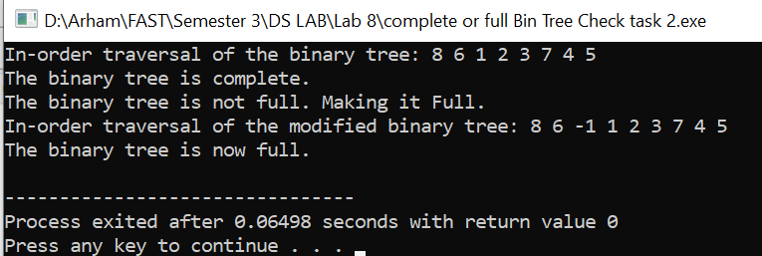

TASK 3:
#include <iostream>
using namespace std;
class Node {
public:
int data;
Node* left;
Node* right;

Node(int value){
data = value;
this->right = NULL;
this->left = NULL;
}
};

class BinarySearchTree {
private:
Node* root;

Node* insert(Node* root, int value) {
if (root == NULL) {
root = new Node(value);
}
else if (value < root->data) {
root->left = insert(root->left, value);
}
else if (value > root->data) {
root->right = insert(root->right, value);
}
return root;
}

public:
BinarySearchTree() : root(NULL) {}

void insertAndLocate(int value) {
root = insert(root, value);

int depth = findDepth(root, value);
if (depth == 0) {
cout << value << " is the root at level " << depth << endl;
}
else if (value < root->data) {
cout << value << " is the left child at level " << depth << endl;
}
else {
cout << value << " is the right child at level " << depth << endl;
}
}

int findDepth(Node* root, int x) {
if (root == NULL) {
return -1;
}

int dist = -1;

if (root->data == x || (dist = findDepth(root->left, x)) >= 0 || (dist = findDepth(root->right, x)) >= 0) {
return dist + 1;
}

return dist;
}

bool search(int value) {
Node* current = root;
while (current) {
if (value == current->data) {
int depth = findDepth(root, value);
if (depth == 0) {
cout << value << " is the root at level " << depth << endl;
}
else if (value < root->data) {
cout << value << " is the left child at level " << depth << endl;
}
else {
cout << value << " is the right child at level " << depth << endl;
}
return true;
}
else if (value < current->data) {
current = current->left;
}
else {
current = current->right;
}
}
return false;
}
};

int main() {
BinarySearchTree bst;
int valueToSearch;

cout << "Enter values to insert into the binary search tree (-1 to stop):" << endl;
int value;
while (true) {
cin >> value;
if (value == -1) {
break;
}
bst.insertAndLocate(value);
}

cout << "Enter a value to search for in the tree: ";
cin >> valueToSearch;

if (!bst.search(valueToSearch)) {
cout << valueToSearch << " does not exist in the tree. Inserting and locating..." << endl;
bst.insertAndLocate(valueToSearch);
}

return 0;
}

OUTPUT:
